 | AUTUMN |  | SPRING |  | SUMMER
 | Emotion of the term:-  Frightened | Emotion of the term:-  Happy | Emotion of the term:-  Sad | Emotion of the term:-  Disgusted | Emotion of the term:-  Angry | Emotion of the term:-  Surprised
Pre-School | 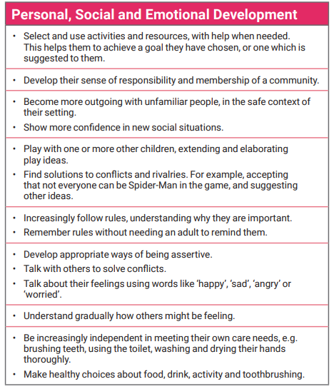
Reception | 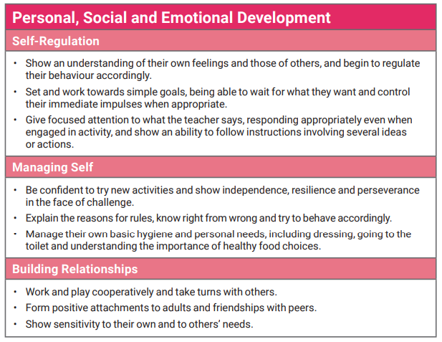
Year 1 | Jigsaw Unit – Healthy Me  (5-6yrs)  (6 Lessons)  This covers:-  - Being healthy  - Hygiene  - Medicine  - Road Safety | Antibullying week  Do bullying lessons from Jigsaw Unit – Celebrating Difference (5-6ys), lessons 3 and 4 | Internet Safety Day  Deliver the Online Safety lesson from Jigsaw (KS1, Lesson 1) | NSPCC Underwear Rule (2 lessons)  Jigsaw Unit – Relationships (5-6yrs)  (6 lessons) |  | Jigsaw Unit  Changing Me  (5-6yrs)  (6 Lessons)  Expect Respect (pgs 26-30) – Friends, Secrets and People who can help us)  (1 Lesson)  In Science, you could deliver the Sun Safety lessons from Jigsaw
Year 2 | Jigsaw Unit – Healthy Me  (6-7yrs)  (6 lessons)  This covers:-  - Being healthy  - Being relaxed  - Medicine  - Healthy eating | Antibullying week  Do bullying lessons from Jigsaw Unit – Celebrating Difference (6-7ys), lessons 3 and 4 | Internet Safety Day  Deliver the Online Safety lesson from Jigsaw (KS1, Lesson 2) | NSPCC Underwear Rule (2 Lessons)  Jigsaw Unit – Relationships (6-7yrs)  (6 lessons)  Expect Respect (pgs 31-36) – Gender, careers and assumptions  (1 Lesson) |  | Jigsaw Unit  Changing Me  (6-7yrs)  (6 lessons)  Water Safety  Lake  (2 Lessons)
Year 3 |  | Jigsaw Unit – Road Safety and Travel Safety  (1 Lesson)  Jigsaw Unit, Healthy Me (7-8yrs)  (6 lessons)  Antibullying week  Do bullying lessons from Jigsaw Unit – Celebrating Difference (7-8ys), lessons 3, 4 and 5 | Internet Safety Day  Deliver Jigsaw, Relationships (7-8yrs), Lesson 3 (Keeping myself safe online)  Fire Safety | NSPCC Underwear Rule  (1 lesson)  Jigsaw Unit – Relationships (7-8yrs)  (5 lessons) |  | Jigsaw Unit  Changing Me  (7-8yrs)  (6 Lessons)  Expect Respect (pgs 37-39) – Resolving conflict and where to get help  (1 lesson)
Year 4 | In Science, you could deliver the Jigsaw Unit, Healthy Teeth and Gums  (1 lesson) | Jigsaw Unit, Healthy Me (8-9yrs)  (6 lessons)  Antibullying week  Do bullying lessons from Jigsaw Unit – Celebrating Difference (8-9ys), lessons 3 and 4 | Internet Safety Day | NSPCC Underwear Rule  (1 lesson)  Jigsaw Unit – Relationships (8-9yrs)  (6 lessons)  Expect Respect (pgs 40-43) – Examining violence, excuses and responsibility  (1 lesson) |  | Jigsaw Unit  Changing Me  (8-9yrs)  (6 lessons)  Water Safety  Jigsaw lesson – Living with Water  (1 lesson)
Year 5 |  | Jigsaw Unit, Healthy Me (9-10yrs)  (6 lessons)  Road Safety  Yorkshire  (1 lesson)  Antibullying week  Do bullying lessons from Jigsaw Unit – Celebrating Difference (9-10ys), lessons 3 and 4 | Internet Safety Day | NSPCC Underwear Rule  (1 lesson)  Jigsaw Unit – Relationships (9-10yrs)  (6 lessons)  Expect Respect (pgs 44-48) – Secrets and stories  (1 lesson) |  | Jigsaw Unit  Changing Me  (9-10yrs)  (6 Lessons)  Jigsaw Unit – Celebrating Difference (9-10yrs), lesson 2 (Racism) and lesson 5 (Does Money Matter)
Year 6 |  | Jigsaw Unit, Healthy Me (10-11yrs)  (6 lessons)  Anti-bullying week  Do bullying lesson from Jigsaw Unit – Celebrating Difference (10-11ys), lesson 4 | Internet Safety Day  Expect Respect (pgs 49-54) –  My Online Identity  (1 lesson) | NSPCC Underwear Rule  (1 lesson)  Jigsaw Unit – Relationships (10-11yrs)  (6 lessons)  Expect Respect (pgs 49-54) – Court Room Game,  (1 lesson) |  | Jigsaw Unit  Changing Me  (10-11yrs)  (6 Lessons)  Water Safety  RNLI  (1 Lesson)  Crucial Crew  STAR Project

