Pupil premium strategy statement – Priorslee Academy- 2023-2024
This statement details our school’s use of pupil premium (and recovery premium) funding to help improve the attainment of our disadvantaged pupils.
It outlines our pupil premium strategy, how we intend to spend the funding in this academic year and the outcomes for disadvantaged pupils last academic year.

School overview
Detail | Data
Number of pupils in school | Priorslee Academy
Proportion (%) of pupil premium eligible pupils | FSM = 14%  Forces = 3%
Academic year/years that our current pupil premium strategy plan covers (3-year plans are recommended) | - – 2023  - – 2024  - - 2025
Date this statement was published | 21st December 2023
Date on which it will be reviewed | July 2024
Statement authorised by | Vicky Lees & Becky Brewer  Acting Heads of School
Pupil premium lead | Jodie Cooper  Head of School (on maternity leave from May 2023)
Detail | Data
Governor / Trustee lead | Sarah Monteith  Reverend Debbie Loughran

Funding overview
Detail | Amount
Pupil premium funding allocation this academic year | £64,020
Recovery premium funding allocation this academic year | £6,815
Pupil premium (and recovery premium*) funding carried forward from previous years (enter £0 if not applicable)  *Recovery premium received in academic year 2021 to  2022 can be carried forward to academic year 2022 to 2023. Recovery premium received in academic year 2022 to 2023 cannot be carried forward to 2023 to 2024. | £0
Total budget for this academic year  If your school is an academy in a trust that pools this funding, state the amount available to your school this academic year | £70, 835

Part A: Pupil premium strategy plan

Statement of intent
At Priorslee Academy, we target the use of Pupil Premium Grant funding to ensure that our disadvantaged pupils receive the highest quality of education to enable them to become active, socially responsible citizens of the future. We recognise that disadvantaged children can face a wide range of barriers which may impact on their learning.
When making decisions about using Pupil Premium funding, it is important to consider the context of the school and the subsequent challenges faced. This is used alongside research conducted by the EEF. There is no “one size fits all”. We have ensured that all teaching staff have been involved in the analysis of data and identification of pupils, so that they are fully aware of strengths and weaknesses across the school.
Our Ultimate Objectives are to:
- Remove barriers to learning created by poverty, family circumstance and background.
- Narrow the attainment gaps between disadvantaged pupils and their non-disadvantaged counterparts both within school and nationally.
- Enable pupils to look after their social and emotional wellbeing and to develop resilience.
- Develop confidence in their ability to communicate effectively in a wide range of contexts.
- Ensure ALL pupils are able to read fluently and with good understanding to enable them to access the breadth of the curriculum.
- Access a wide range of opportunities to develop their knowledge and understanding of the world.

Our Context:
Priorslee Primary School converted to an academy in 2011. Upon conversion to academy status, the existing school closed, and the new school opened in its place. Priorslee Academy is a large, two-form entry school in Priorslee, Telford. Priorslee Academy is extremely fortunate to be set in beautiful and extensive grounds.
The school has provision for three and four-year-olds in its attached to the school ‘Little Seedlings’. The proportion of pupils known to be eligible for free school meals is well below the national average at 14%. The school currently has 447 pupils on site (including pre-school), with 31% of pupils are from minority ethnic backgrounds groups. 25% of children in school are identified as EAL.

Achieving our Objectives:
In order to achieve our objectives and overcome identified barriers to learning, we will:
- Provide all teachers with high quality CPD to ensure that pupils access effective quality first teaching.
- Appoint experienced teachers to provide outstanding quality first teaching opportunities.
- Guarantee that team leaders and subject leaders have adequate release time, in order to monitor, and undertake coaching to improve the quality of teaching and learning across the school.
- Provide targeted intervention and support to quickly address identified gaps in learning including the use of small group work and 1:1 tuition.
- Allocate learning support assistants to provide small group work focussed on overcoming gaps in learning every afternoon.
- Target funding to ensure that all pupils have access to trips, residentials and first-hand learning experiences.
- Provide opportunities for all pupils to participate in enrichment activities including sport and music.
- Provide appropriate nurture from our pastoral team to support to enable pupils to access learning within and beyond the classroom.
- This is not an exhaustive list and strategies will change and develop based on the needs of individuals.

Challenges
This details the key challenges to achievement that we have identified among our disadvantaged pupils.
Challenge number | Detail of challenge
1. Mental Health and Wellbeing | A number of pupils are struggling with anxiety and the ability to separate from parents in order to come to school, which is affecting their academic progress and their attendance.
2. Social and  Emotional Skills | Some pupils are struggling to regulate their emotions and lack the social understanding needed in order to form effective relationships with their peers.
3. Reading, Writing and Maths | There is an attainment gap between pupils in receipt of pupil premium funding compare to those who do not receive this funding.
4. Phonics and Early Reading | Developing early reading for all and addressing gaps in pupils’ knowledge of phonics.
5. Access to wider opportunities | A number of pupils do not access enrichment experiences outside of the school experience.

Intended outcomes
This explains the outcomes we are aiming for by the end of our current strategy plan, and how we will measure whether they have been achieved.
Intended outcome | Success criteria
Pupils are more willing to come to school (display reduced anxiety). | An improvement in attendance levels (including lateness).
Pupils are more able to self-regulate and manage emotions in appropriate ways. | CPOMS logs show a reduction in negative incidents.  Pupils form effective relationships with their peers.
Narrowing the attainment gap for pupils in receipt of Pupil Premium compared to their peers | Pupil data shows PP children achieving the same as their peers
Narrow the gap between non PP and PP pupils passing the Year One Phonics Screening Check | Pupil data from the screening check shows an upward trend of PP passing the screening check
Children are experiencing wider opportunities. | An increase in pupil premium children accessing wider opportunities e.g. residential visits and trips

Activity in this academic year
This details how we intend to spend our pupil premium (and recovery premium) funding this academic year to address the challenges listed above.

Teaching (for example, CPD, recruitment and retention)
Budgeted estimated cost: £47, 025
Activity | Evidence that supports this approach | Challenge number(s) addressed
High Quality Teaching: High quality teaching and curriculum  Appointment of four TLR positions (Phonics/EYFS, Maths, Writing and Reading). A focus on raising standards through planning, modelling and team-teaching, as well as monitoring teaching and learning.  TLR payments =£12, 068  TLR release time= £10, 336 | EEF Effective Professional Development for Staff  EEF-Effective-Professional-Development-Guidance-Report.pdf (d2tic4wvo1iusb.cloudfront.net)  High quality teaching improves pupil outcomes and effective professional development offers a crucial tool to develop teaching quality and subsequently enhance children’s outcomes in the classroom  . | 3 & 4
High Quality Teaching: Assessment  Purchase of Standardised  Assessments & Intervention Therapies (PiXL)  £2500 | EEF Teaching and Learning Toolkit (+6 months)  Feedback | EEF (educationendowmentfoundation.org.uk)  Providing feedback is a well-evidenced and has a high impact on learning outcomes. Effective feedback tends to focus on the task, subject and self-regulation strategies: it provides specific information on how to improve. | 3 & 4

High Quality Teaching: appointment and retention of experienced teachers  £22, 121 | Appointment of two experienced teachers for Key Stage 2 from September 2023 (one at M5 and one at UPS2).  Sutton Trust Developing Teachers : Sutton Trust Report on Teacher Development  Good instruction includes elements such as effective questioning and use of assessment by teachers. Specific practices, like reviewing previous learning, providing model responses for students, giving adequate time for practice to embed skills securely and progressively introducing new learning (scaffolding) are also elements of good quality instruction. | 3 & 4

Targeted academic support (for example, tutoring, one-to-one support, structured interventions)
Budgeted estimated cost: £ 17, 193
Activity | Evidence that supports this approach | Challenge number(s) addressed
Targeted Academic Support: Intervention to support phonics and early reading development.  Phonics Interventions with  Support Assistants for  Key Stage One and Year 3 pupils  £5,008 | EEF Teaching and Learning Toolkit (+5 months)  Phonics | EEF (educationendowmentfoundation.org.uk)  Phonics is an approach to teaching some aspects of literacy, by developing pupils’ knowledge and understanding of the relationship between written symbols and sounds. This involves the skills of hearing, identifying and using the patterns of sounds or phonemes to read written language. The aim is to systematically teach pupils the relationship between these sounds and the written spelling patterns, or graphemes, which represent them. Phonics emphasises the skills of decoding new words by sounding them out and combining or ‘blending’ the sound-spelling patterns. | 3 & 4
Targeted Academic Support:  Targeted interventions before school in each year group, delivered by learning support staff.  £3,420 | EEF Teaching and Learning Toolkit (+4 months)  Teaching Assistant Interventions | EEF  (educationendowmentfoundation.org.uk)  Targeted deployment, where teaching assistants deliver an intervention to small groups or individuals that has a higher impact. | 1, 3 & 4
Targeted Academic Support: use of technology to improve learning (writing)  Clicker (one school site license)  £1, 306 | EEF Teaching and Learning Toolkit  EEF_Digital_Technology_Guidance_Report.pdf (d2tic4wvo1iusb.cloudfront.net)  Use of technology (Clicker) to improve pupils’ access and engagement for writing. This programme has been recommended by the learning Support Advisory Team throughout the year. | 3
Targeted Academic Support: Targeted intervention plans in each year group delivered by teaching staff.  £7, 459 | EEF Teaching and Learning Toolkit (+4 months impact)  Teaching Assistant Interventions | EEF  (educationendowmentfoundation.org.uk)  Small group tuition is defined as one teacher or professional educator working with two to five pupils together in a group. This arrangement enables the teacher to focus exclusively on a small number of learners, usually in a separate classroom or working area. Intensive tuition in small groups is often provided to support lower attaining learners or those who are falling behind, but it can also be used as a more general strategy to ensure effective progress, or to teach challenging topics or skills.

Wider strategies (for example, related to attendance, behaviour, wellbeing)
Budgeted estimated cost: £30, 036
Activity | Evidence that supports this approach | Challenge number(s) addressed
Wider Strategies: Supporting pupils’ social, emotional and behavioural needs.  ELSA Trained Member of Support Staff with 1 day per week release time.  £3, 736 | EEF Teaching and Learning Toolkit (+4 months impact)  Social and emotional learning | EEF  (educationendowmentfoundation.org.uk)  Social and emotional learning (SEL) interventions seek to improve pupils’ decision-making skills, interaction with others and their self-management of emotions, rather than focusing directly on the academic or cognitive elements of learning. Social and emotional learning approaches have a positive impact, on average, of 4 months’ additional progress in academic outcomes over the course of an academic year. | 1 & 2

Wider Strategies: Supporting pupils’ social, emotional and behavioural needs.  Behaviour and Emotional Support interventions with the Pastoral Lead.  £20, 000 | EEF Teaching and Learning Toolkit (+4 months impact)  Behaviour interventions | EEF  (educationendowmentfoundation.org.uk)  Behaviour interventions seek to improve attainment by reducing challenging behaviour in school. This entry covers interventions aimed at reducing a variety of behaviours, from low-level disruption to aggression, violence, bullying, substance abuse and general anti-social activities. | 1 & 2
Wider Strategies: Communicating and Supporting Parents  Time for Pastoral lead to meet with parents to offer support.  £2, 800 | EEF Teaching and Learning Toolkit (+4 months impact)  Parental engagement | EEF  (educationendowmentfoundation.org.uk)  Parental engagement refers to teachers and schools involving parents in supporting their children’s academic learning. It includes:  • approaches and programmes which aim to develop pa-  rental skills such as literacy or IT skills;  • general approaches which encourage parents to sup-  port their children with, for example reading or home-  work;  • the involvement of parents in their children’s learning activities; and  • more intensive programmes for families in crisis. | 1 & 2

Wider Strategies:  Extracurricular activities  Personalised budget (£50 per child), which allows families to access residentials, trips and excursions.  £3, 500 | EEF Teaching and Learning Toolkit (+3 months impact)  Arts participation | EEF  (educationendowmentfoundation.org.uk)  Arts participation is defined as involvement in artistic and creative activities, such as dance, drama, music, painting, or sculpture. It can occur either as part of the curriculum or as extra-curricular activity. Arts-based approaches may be used in other areas of the curriculum, such as the use of drama to develop engagement and oral language before a writing task. | 1 & 2

Total estimated budgeted cost: £ 91, 754

Part B: Review of the previous academic year 2022-2023

Outcomes for disadvantaged pupils
Our Pupil Premium Strategy has been mainly unaltered since last year’s published document.

National Data 2022-2023:

Early Years Good Level of Development
Early Years Foundation Stage | Priorslee – All Pupils  (49 pupils) | Priorslee – Disadvantaged Pupils  (7 pupils)
2022-2023  (49 pupils in cohort) | 71%  (35 pupils) | 43%  (3 pupils)

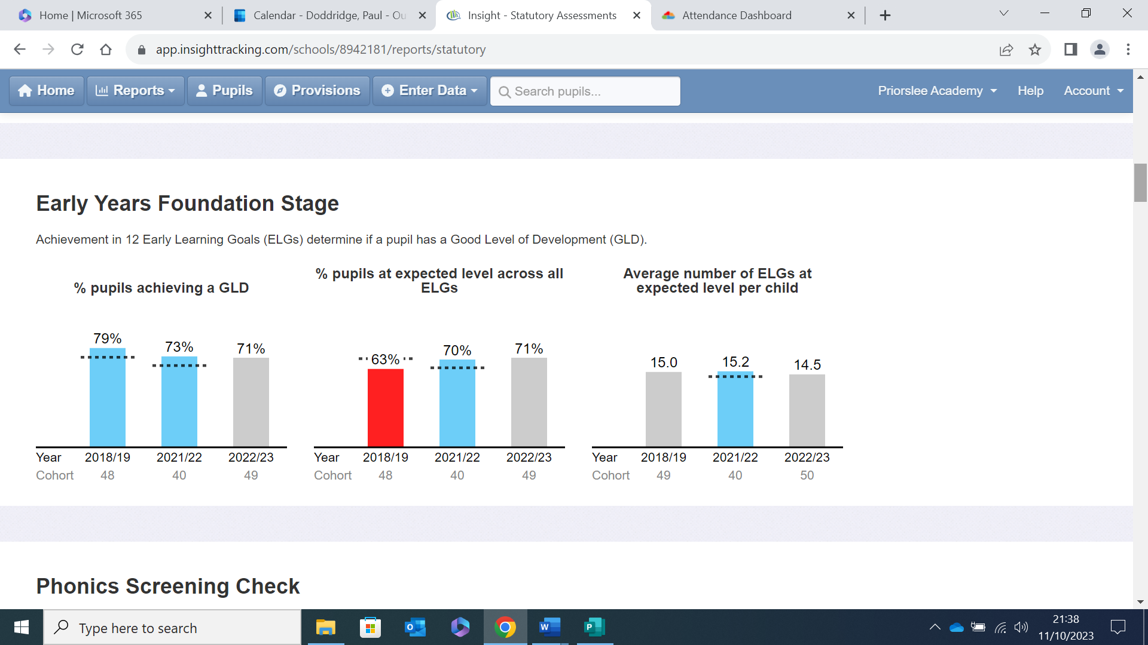

Phonics
Year 1 Phonics Screening Check
Children scoring 32 or more (achieve the phonics standard)
 | Priorslee – All Pupils  (53 pupils) | Priorslee – Disadvantaged Pupils  (9 pupils)
2022-2023  (53 pupils) | 79%  (42 pupils) | 78%  (7 pupils)
2022-2023 (National) | 79%
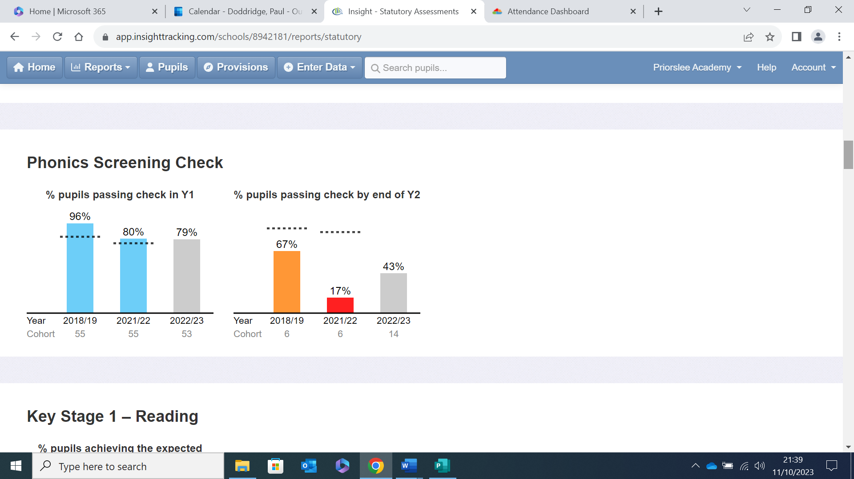

Key Stage 1 (Year 2) SATs (2023)
Cohort 60 pupils | READING |  | WRITING |  | MATHS |  | SCIENCE | Read, write & Maths combined  (EXS or better) | Read, write & Maths combined  Greater Depth
 | Expected+ | Greater Depth | Expected+ | Greater Depth | Expected+ | Greater Depth | Expected+
2023 | 69%  (41 pupils) | 12%  (7 pupils) | 56%  (33 pupils) | 8%  (5 pupils) | 66%  (39 pupils) | 7%  (4 pupils) | 75% | 30%  (30 pupils) | 4%  (2 pupils)
Priorslee 2023  Disadvantaged pupils  (8 pupils) | 50%  (4 pupils) | 0% | 25%  (2 pupils) | 0% | 50%  (4 pupils) | 0% | 50%  (4 pupils) | 25%  (2 pupils) | 0%
2023  National | 68% |  | 60% |  | 70%
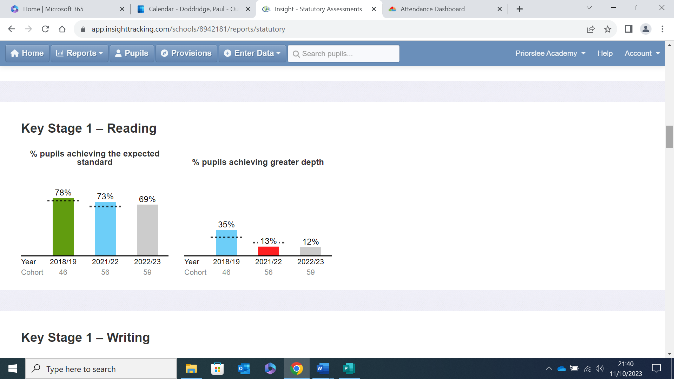

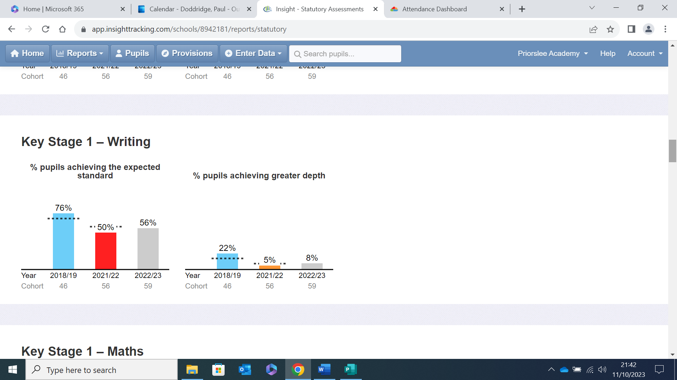

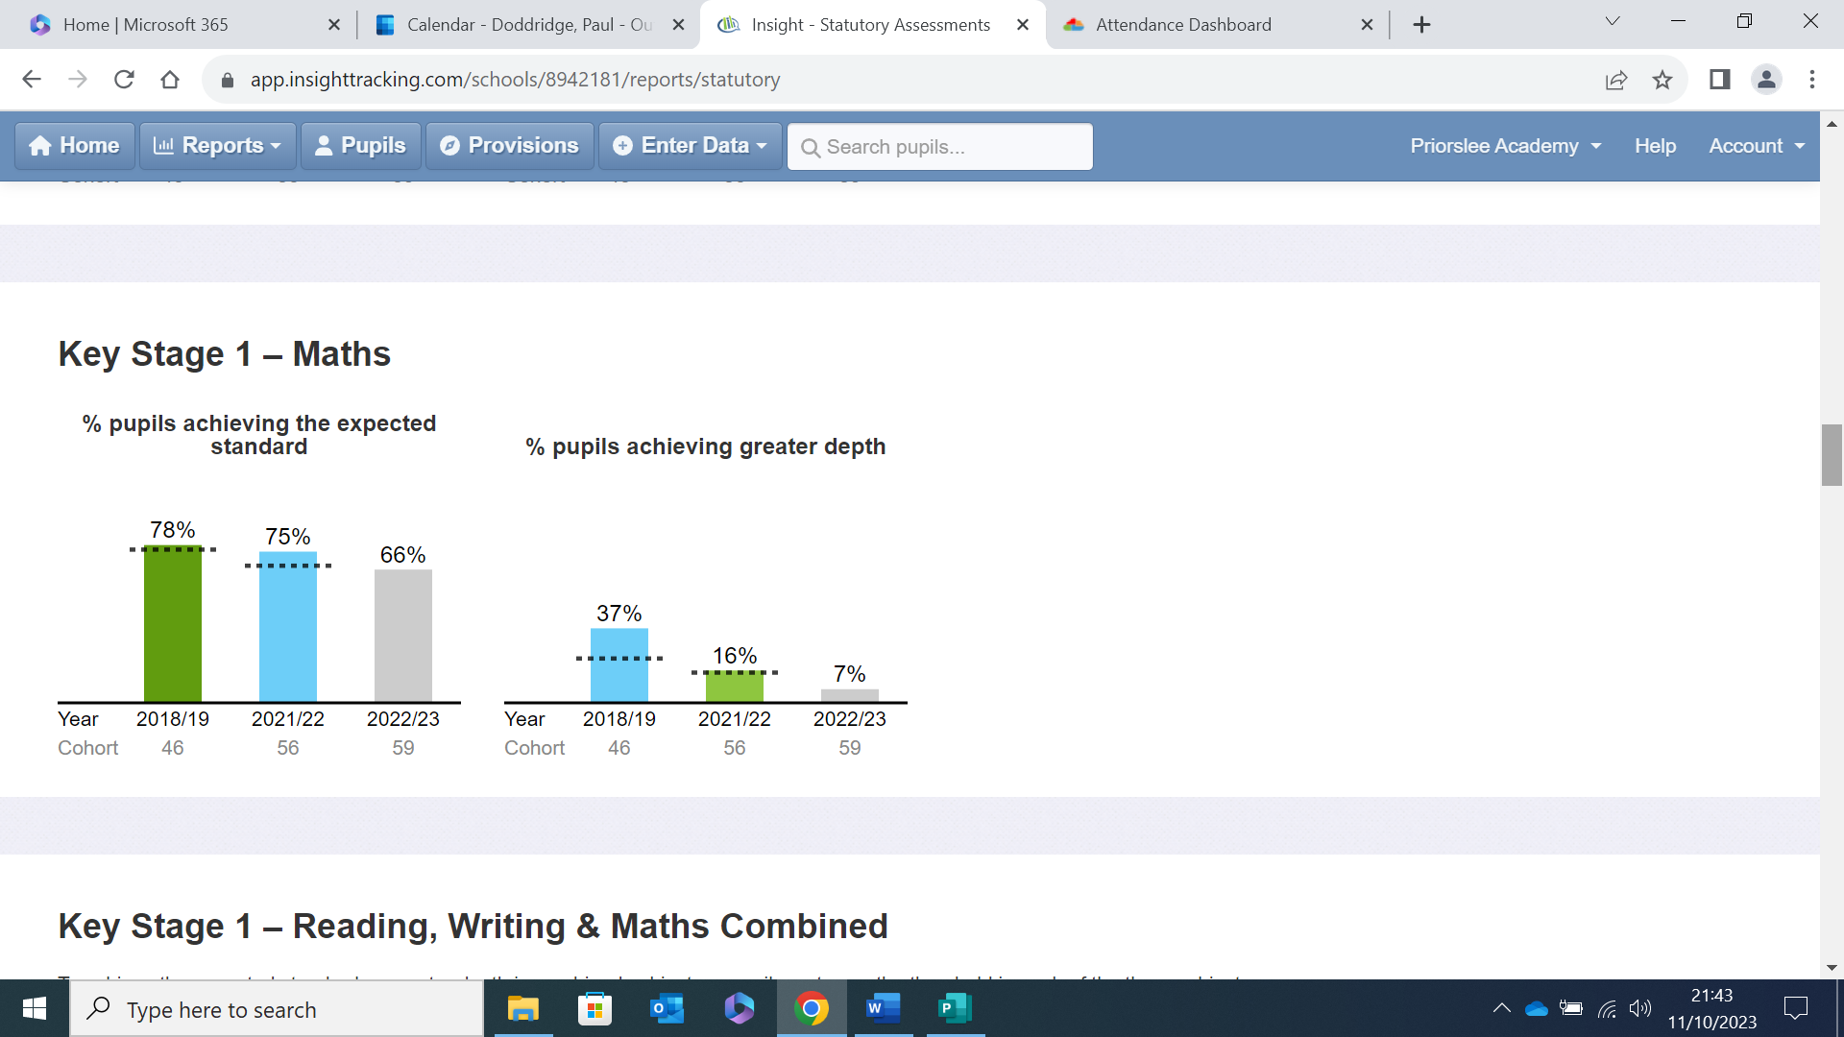

Key Stage 2 (Year 6) SATs
 |  | Priorslee 2023  (65 pupils) | National 2023 | Priorslee 2023  (disadvantaged pupils achieving EXS- 5 pupils)
Reading | Expected + | 80%  (52 pupils) | 73% | 40%  (2 pupils)
 | Greater Depth | 29%  (19 pupils) |  | 0%
Writing | Expected + | 80%  (52 pupils) | 71% | 60%  (3 pupils)
 | Greater Depth | 27%  (17 pupils) |  | 0%
Maths | Expected + | 83%  (54 pupils) | 73% | 20%  (1 pupil)
 | Greater Depth | 26%  (17 pupils) |  | 0%
Read, write & Maths combined | Expected + | 66%  (43 pupils) | 59% | 20%  (1 pupil)
 | Greater Depth | 12%  (8 pupils) |  | 0%
Spelling, punctuation & grammar | Expected + | 78%  (51 pupils) | 78% | 60%  (3 pupils)
 | Greater Depth | 37%  (24 pupils) |  | 0%
Science | Expected | 91%  (58 pupils) | 80% | 80%  (4 pupils)

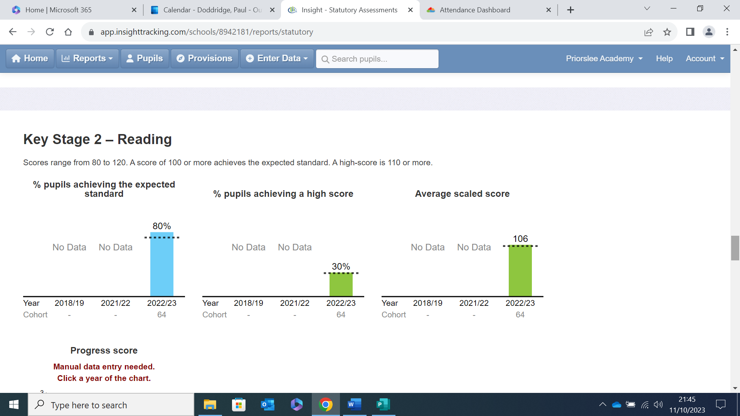

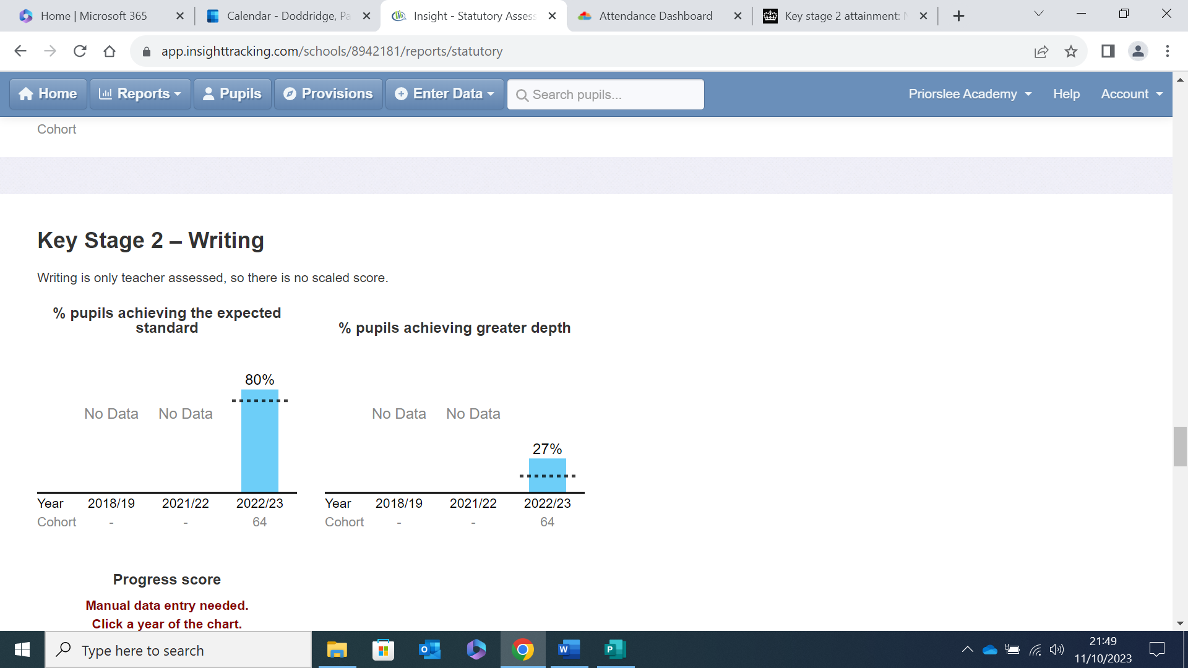

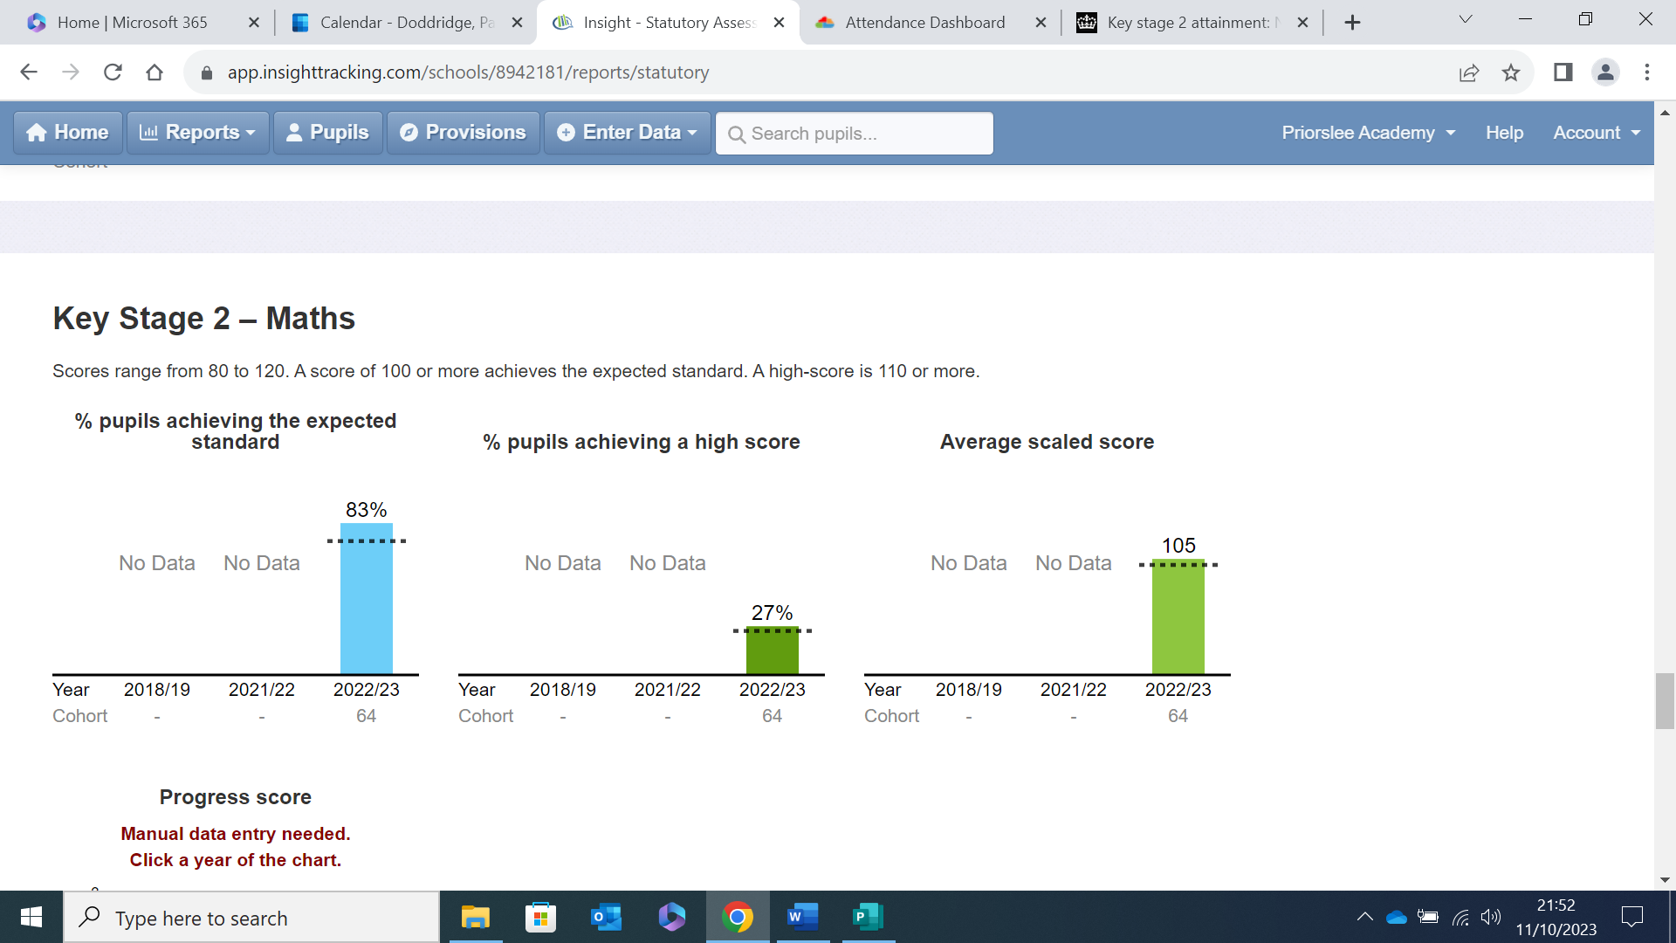

Externally provided programmes
Please include the names of any non-DfE programmes that you used for your pupil premium (or recovery premium) to fund in the previous academic year (2022-2023)
Programme | Provider
Catch Up Literacy and Numeracy | Catch Up Interventions
ELKLAN (3-5 years) | ELKLAN
WELLCOMM | WELLCOMM
1:1 specialist dyscalculia Maths tutoring | Jane James
Emotional Coaching | Telford and Wrekin Educational Psychology Team
Beanstalk Reading Volunteer | Beanstalk Reading Programme

