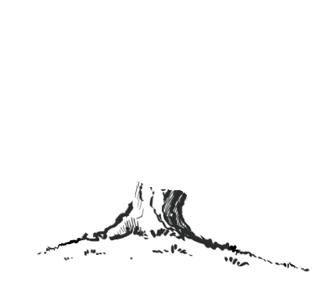
Physical Education
Spring 1:
Yoga
Target Games
Spring 2:
Fitness
Invasion Games

Design Technology
Cooking & Nutrition
(Preparing fruit and vegetables)
Art
Working in 3D
Architecture, Drawing, Sketchbooks, Collage, Making
ACCESS ART
Be An Architect
Artists:
Hundertwasser, Zaha Hadid, Heatherwick Studios

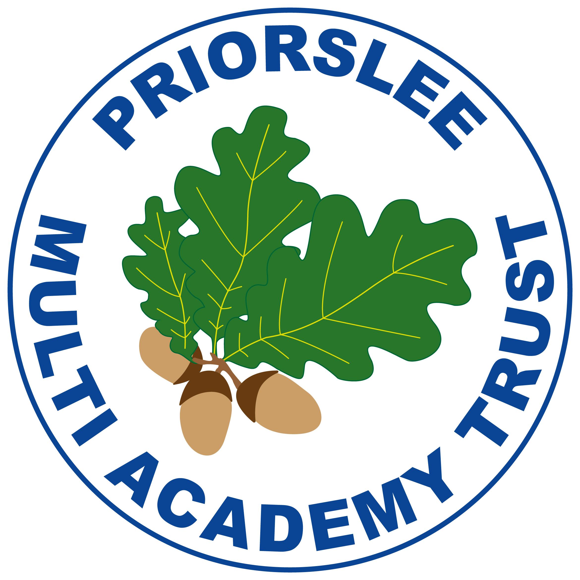
Year 2
SPRING

Mathematics
Time
Fractions
Add and subtract 2-digit numbers
Money
Face, Shapes and Patterns
History
‘Flying through the ages’
Children will explore the first ‘flight’, significant people who invented and engineered the first flight and how we learnt to fly.

Geography
‘Hot and Cold places’
Children will explore north and south poles, continents, countries around the equator and recognise features of hot and cold places.

Religious Education
Respect for everyone – what does that mean?
RSHE
Safer Internet Day
NSPCC Underwear Rule
Relationships
Expect Respect
Gender, careers and assumptions

English
Phonics/Spelling: Focusing on different spelling rules each week. Handouts provided after Little Wandle sessions.
Reading: We read a whole class text 3 times per week focussing on key reading skills. (VIPERS.) We look at both fiction and non-fiction texts.
English topics:
Based around the book ‘The Dragon Machine.’
Character Description and Adventure Narrative.
Based around the book ‘I Wanna Iguana.’
Non-Chronological Report (Fictional)
Persuasive Letter
We practice handwriting daily,

Science
Materials
Plastics (Sustainability)
Computing
Creating Media
Internet Safety
Programming
Music
I wanna play in a band
&
Zootime
Sing, play, improvise and compose

