
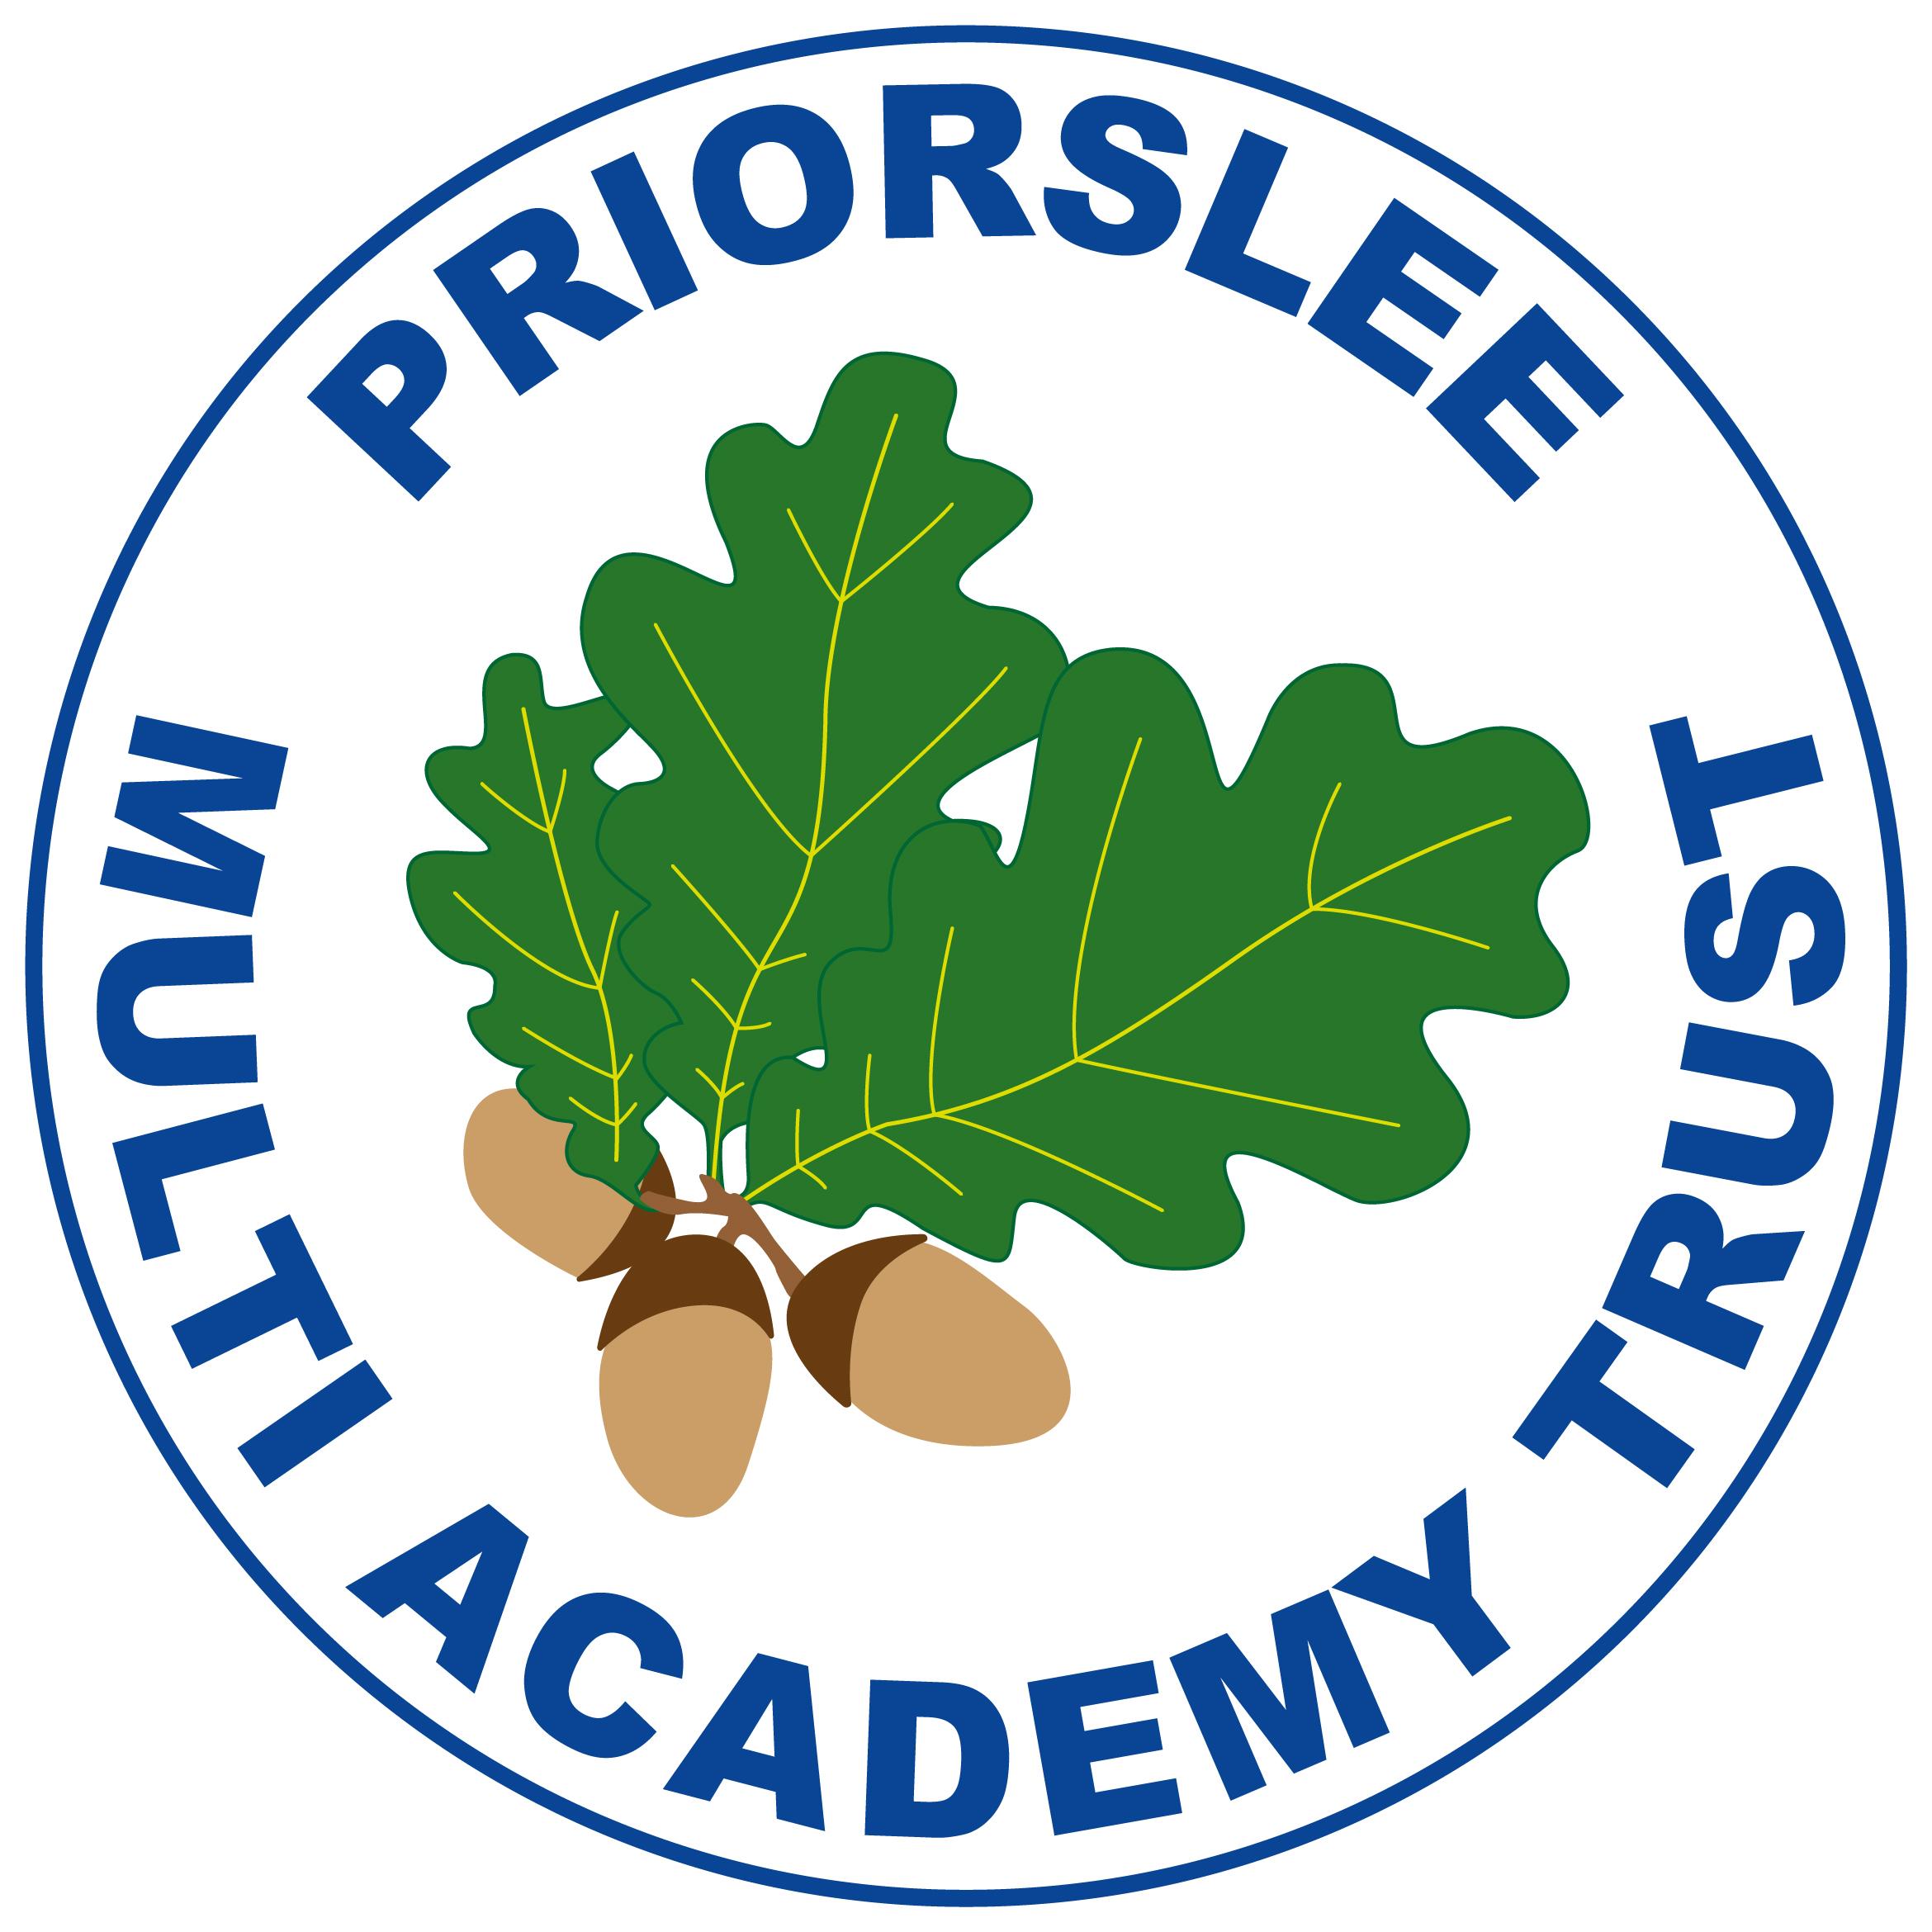
Year 3
Summer Term

French
Carnival and Numbers
The Hungry Giant
Going on a picnic/Where I live
Science
Plants
Biodiversity
Food Waste
English
Spelling: Spelling rules for dis-, mis-, in-, im-, il-, ir-, -able, -ible, ex-, anti-, multi-, -vent- and -vene-
Reading: 3 lessons per week focussing on reading comprehension skills using extracts from a variety of books.
Class novels: Anisha, Accidental Detective by Serena Patel, The Hodgeheg by Dick King Smith
English topics: Poetry, Character Description, Informative leaflet

Mathematics
Fractions
Angles and Shapes
Measures
Applying multiplicative thinking
Exploring calculation strategies and place value

Geography
Where does our food come from?
History
Ancient Greece
Religious Education
Is life like a journey?
RSHE
Changes
Resolving conflict and where to get help

Computing
Online Safety
Graphing
Coding

Music
Bringing Us Together
Opening Night

Design Technology
Cooking and Nutrition

Art
3D sculpture and drawing

Physical Education

PE topics: Tennis, Cricket, Athletics, Outdoor Adventure Activities

